XYZ District Day Camp
June 1-5, 2017
Time
Location
Grab your sunglass, sunscreen and beach towel for an island adventure. Day Camp is for Cub Scouts entering 1st through 5th grade next school year. Going to camp is a wonderful part of the Cub Scouting experience, and offers unforgettable experiences and memories. Participants will receive a t-shirt and patch.

Scouts will learn outdoor skills, shoot archery and BB guns, enjoy STEM activities, play sports, earn advancements, make crafts, and more.

Register before March 13, 2017, and receive a limited-edition cap. Early registration ends March 6, 2017.
Advancements
Scouts will be working towards achieving parts of the following advancements.
 |  | Tigers (1st grade)  - Curiosity, Intrigue, and  Magical Mysteries  - Good Knights  - Floats and Boats  - Stories in Shapes  - Tiger Theater  Wolf (2nd grade)  - Air of the Wolf  - Code of the Wolf  - Finding Your Way | Bear (3rd grade)  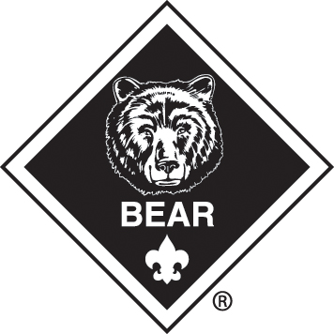  - Bear Claws  - Baloo the Builder  - Make It Move  - Super Science  Webelos (4th grade)  - First Responder  - Art Explosion  - Build It  - Engineer  Webelos (5th grade)  Introduction to Boy Scouting skills (e.g., knots, first aid, orienteering, camping

Adult Volunteers. Day camps are a 100 percent volunteer effort. To ensure a successful and safe day camp program, volunteers are needed to assist the staff and guide the Cub Scouts through each day’s activities. Packs must provide a minimum of one adult volunteer each day for every four boys attending each camp from your pack.
www.district-name.shac.org/day-camp

